Aligned to Cod (no Haddock available); 0.700 confidence; merge term similarity >=0.8

90% CpGs
Cluster 1 (hypomethylated with age) = 26,239 CpGs, 860 genes with 10+ age-associated CpGs, 671 protein sequences, 98 enriched terms
- 559 nodes + 245 edges
- Average node degree = 0.877
- Average local clustering coefficient = 0.204
- Expected number of edges = 168
- PPI enrichment p-value = 1.38e-08
- 22 sub-networks
  - Sub-network 1 = 119 genes (nodes)
  - Sub-network 2 = 9 genes (nodes)
  - Sub-network 3 = 5 genes (nodes)

Sub-network 1 = 196 enriched terms
- 119 nodes + 198 edges
- Average node degree = 3.33
- Average local clustering coefficient = 0.515
- Expected number of edges = 58
- PPI enrichment p-value = <1.0e-16

Cluster 2 (hypermethylated with age) = 41,602 CpGs, 692 genes with 10+ age-associated CpGs, 551 protein sequences, 75 enriched terms
- 461 nodes + 178 edges
- Average node degree = 0.772
- Average local clustering coefficient = 0.202
- Expected number of edges = 117
- PPI enrichment p-value = 9.7e-08
- 20 sub-networks
  - Sub-network 1 = 90 genes (nodes)
  - Sub-network 2 = 9 genes (nodes)
  - Sub-network 3 = 7 genes (nodes)

Sub-network 1 = 143 enriched terms
- 90 nodes + 138 edges
- Average node degree = 3.07
- Average local clustering coefficient = 0.533
- Expected number of edges = 34
- PPI enrichment p-value = <1.0e-16

Clock CpGs
Cluster 1 (hypomethylated with age) = 30 CpGs, 27 genes, 17 protein sequences
** couldn’t filter to 0.700 high confidence; sitting at medium confidence
- 10 nodes + 1 edge
- Average node degree = 0.2
- Average local clustering coefficient = 0.2
- Expected number of edges = 0
- PPI enrichment p-value = 0.064
- 1 enriched term = Disulfide bond KW-1015

Cluster 2 (hypermethylated with age) = 79 CpGs, 85 genes, 46 protein sequences
- 39 nodes + 1 edge
- Average node degree = 0.0513
- Average local clustering coefficient = 0.0513
- Expected number of edges = 1
- PPI enrichment p-value = 0.48
- No functional enrichment terms

Cluster 1 hypomethylated with age summary:
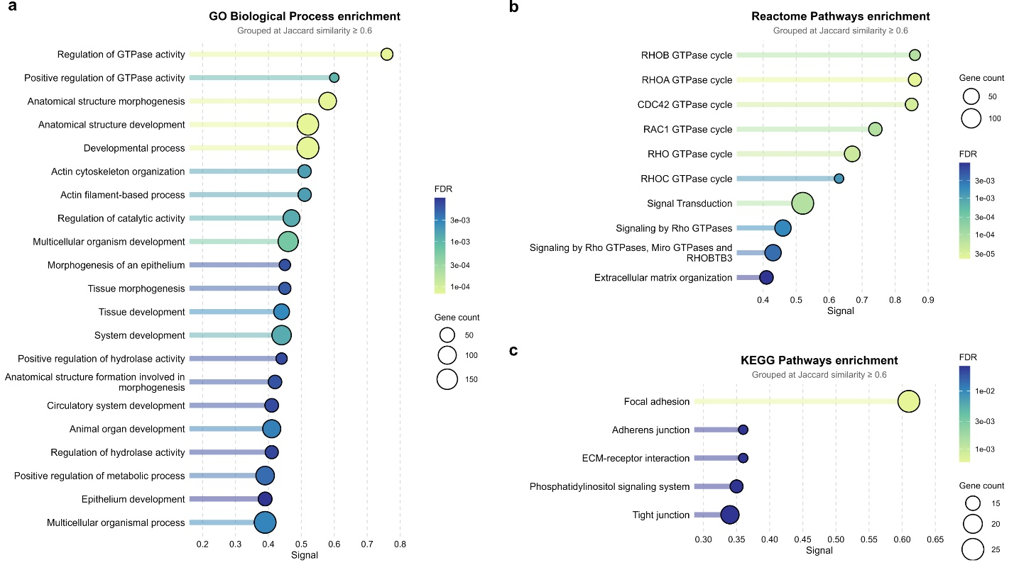

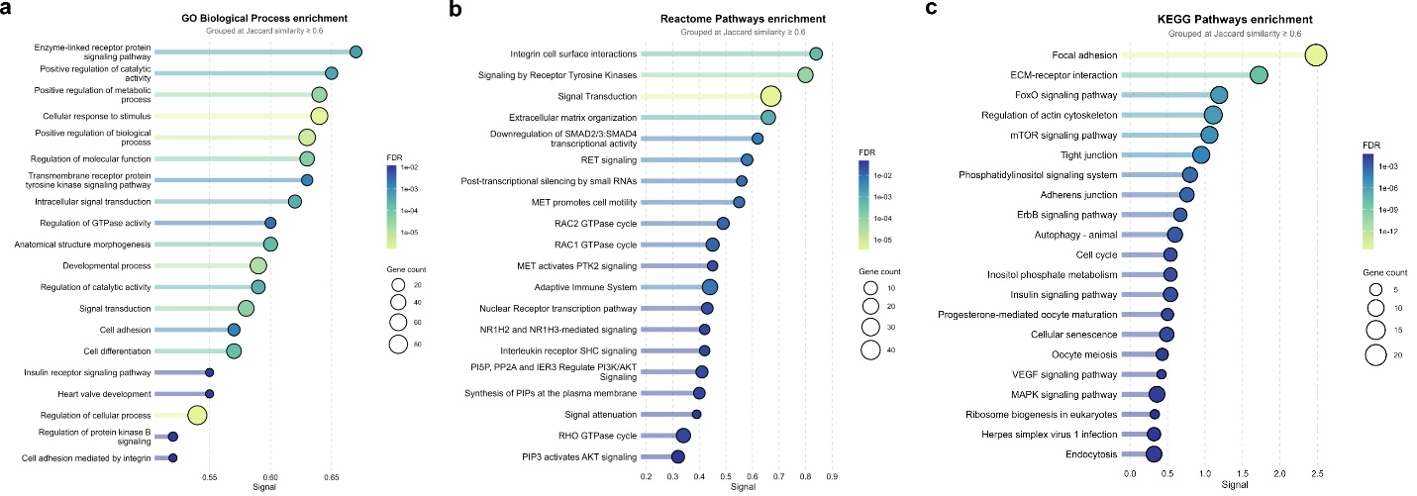

Cluster 2 hyper methylated with age:

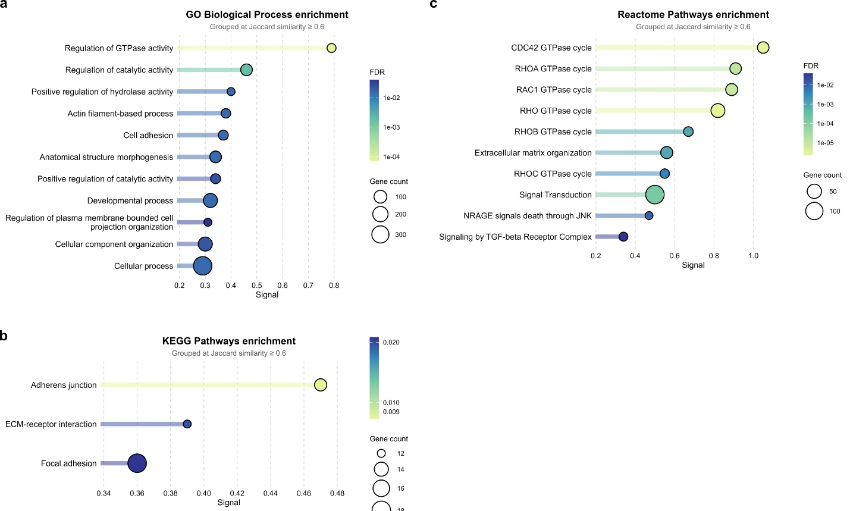

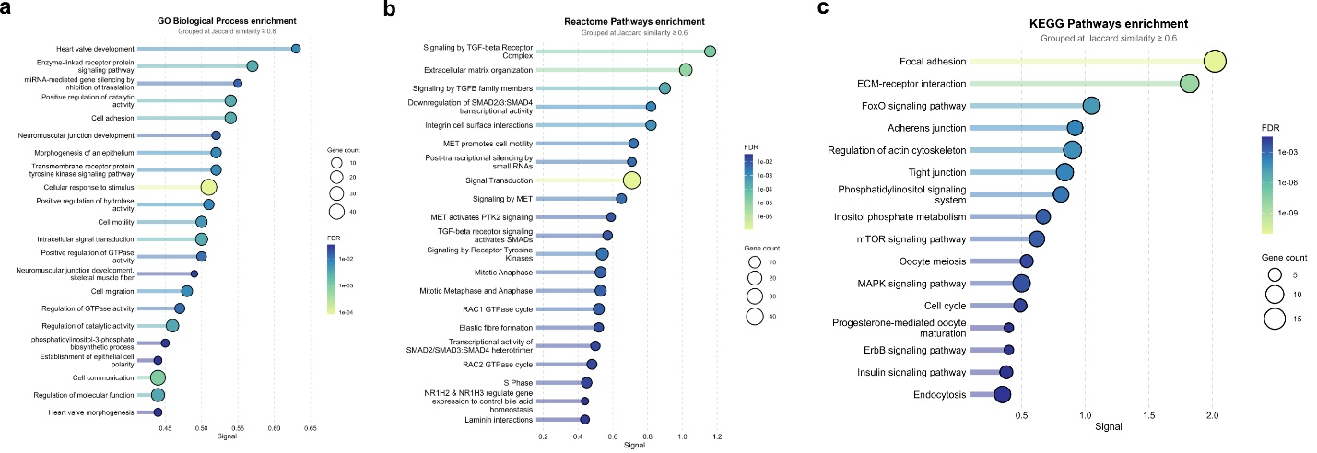

Similar themes overall…

What is the overlap in these gene lists? Are there areas of methylation shifting on the same genes?

